**Ligʷiɫdax̌ʷ Village Sites Special thanks to First Peoples Cultural Council**

**Indigenous Heritage Micro Grants**

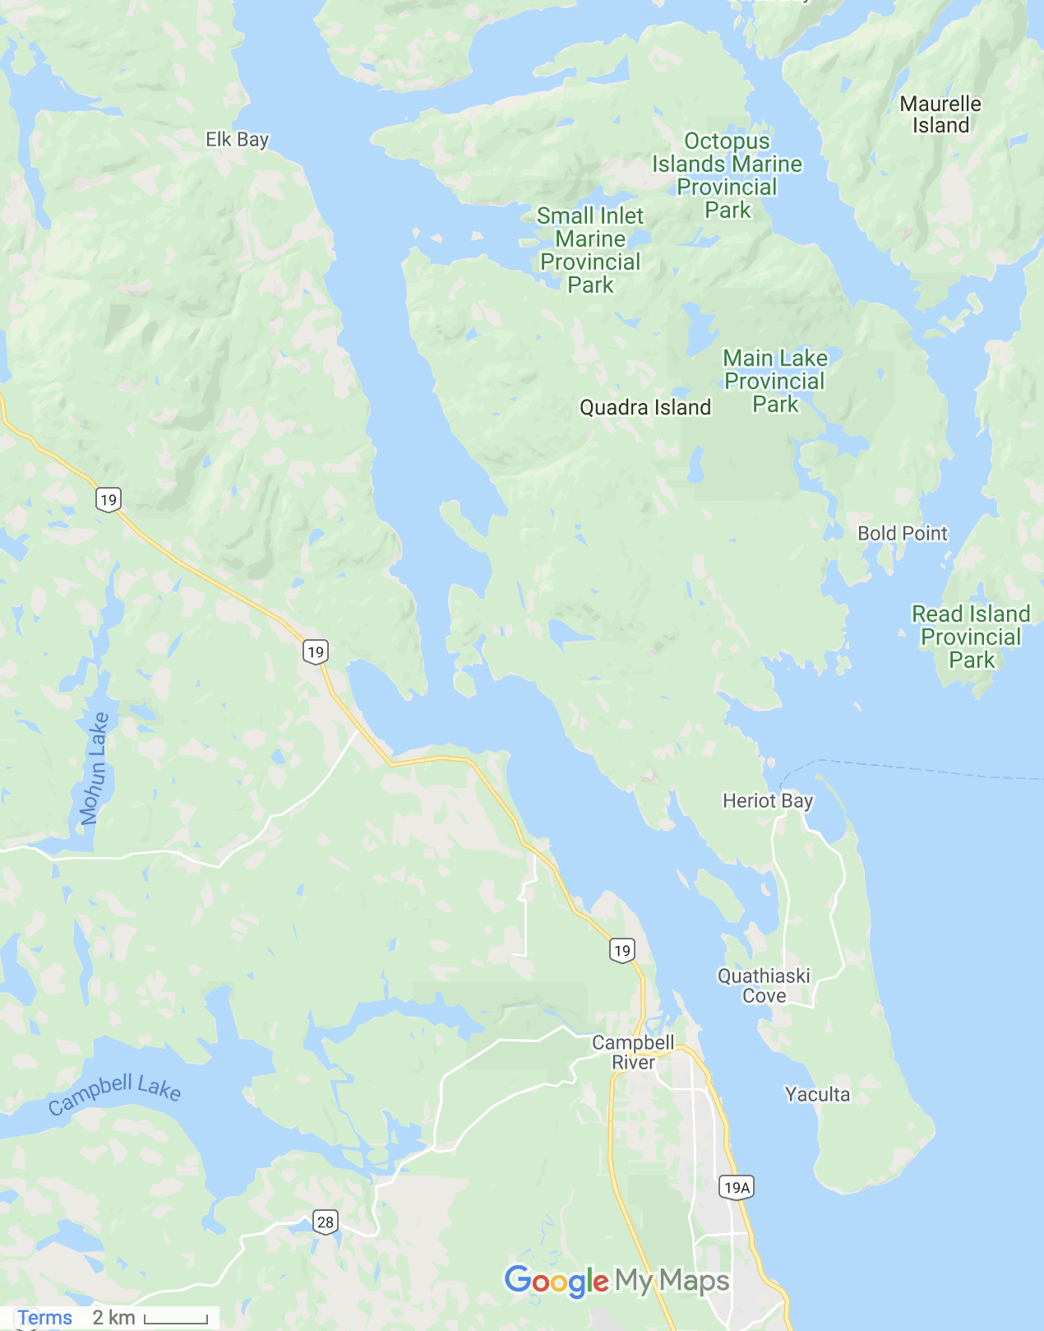

**Village Names for Quadra and Campbell River Areas:**

1. ʔuʔtəwi Seymour Narrows
2. ʔuxʷsola Okisollo Channel
3. C̓əqʷəlutən Cape Mudge Village Indian Reserve #10
4. ƛ̓amataxʷ Campbell River Village Indian Reserve #11
5. ʔaƛigalis Place of doing fish by Old CR Spit Field
6. ʔuxʷstalis Tyee CR Spit
7. M̓əǧʷisdᶻi Big Rock
8. Qᵂənsam Quinsam Indian Reserve #12
9. Gʷak̓utciwi Painters Lodge Area North Side of River Mouth
10. Gʷagəmlis Duncan Bay
11. Pəlaqolis Middle Point
12. ʔəɫ Menzies Bay
13. ƛəmqʷilaba Race Point
14. Puqʷicən Browns Bay
15. G̓əldis Elk Bay
16. Ǧagoləm Rock Bay
17. Quyumin Little Bear River
18. Q̓ucumin Bear River
19. Hoxʷholəlmikʷ Chamelean Harbour
20. Q̓anis Granite Bay
21. Wayad Wyyat Bay
22. T̓aqi Deepwater Bay
23. Nalitʔaqi Plumper Bay
24. Məkʷəstoy Maud Island
25. Gaɫbatikʷ stream on Quadra parallel with Race Point
26. Qʷiqʷəx̌uɫ Copper Bluffs
27. Gəlt̓ənƛi Steep Island
28. Gʷigʷakulis Gowlland Harbour
29. M̓əgʷigi Island by April Point
30. Həmx̌ʷəmaʔas Cliffs near Gowlland Harbour
31. Gʷanusbi Upper Quathiaski Cove
32. ʔunƛemalʔis Camp near lighthouse where Salish would camp
33. ʔugʷitəmalis Head of Quadra Islands
34. ƛax̌ʷməsdᶻisbalis Willow Point
35. Ǧax̌am Oyster River
36. Məƛənac Mitlenatch Island
37. X̌ʷax̌ʷəʔegʷawas Dog Fish Bay East side Quadra place to make dogfish oil
38. C̓aɫc̓ax̌isam Drew Harbour Indian Reserve #9 Rebecca Spit
39. Mədᶻekʷamin Hyacinthe Bay
40. ƛaxʷayəm Open Bay Indian Reserve #8
41. Yakʷən Village Bay Indian Reserve #7
42. Lix̌c̓o Oyster Bay
43. Qaw̓icən Mouth of Stream from Morte Lake

**Petroglyphs are marked P1-11

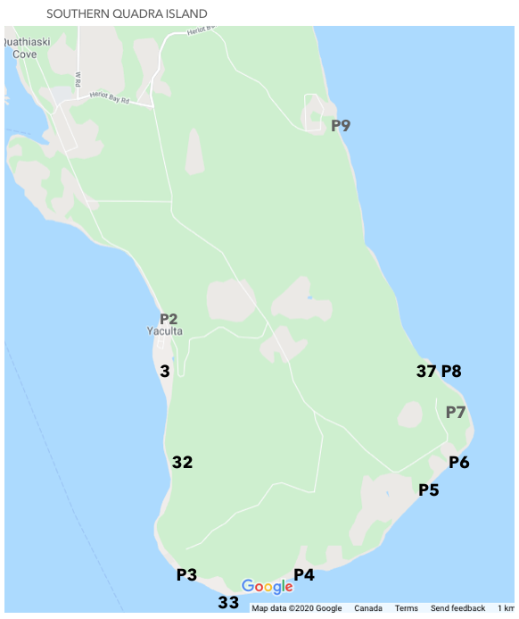

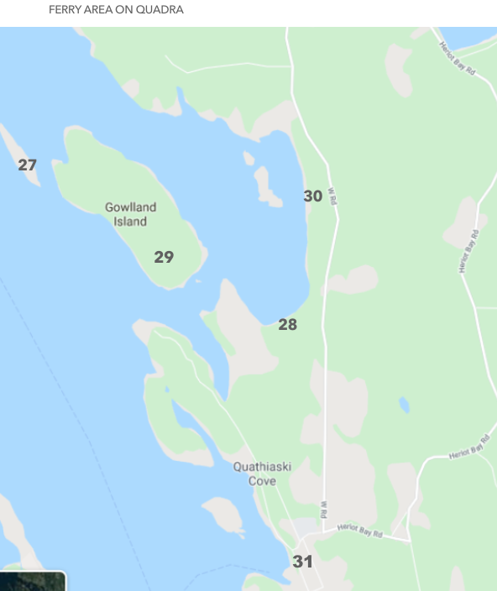

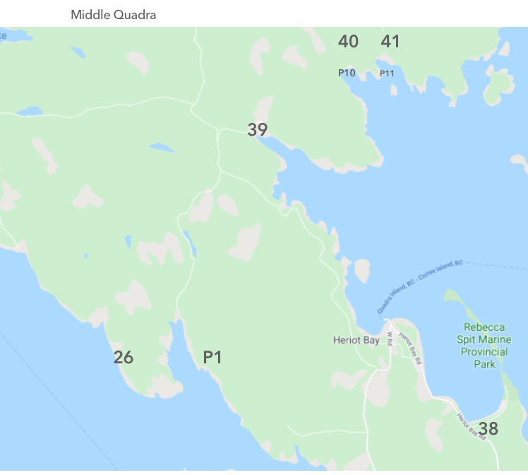

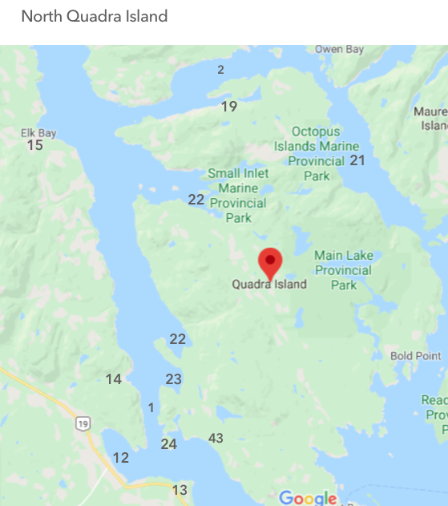

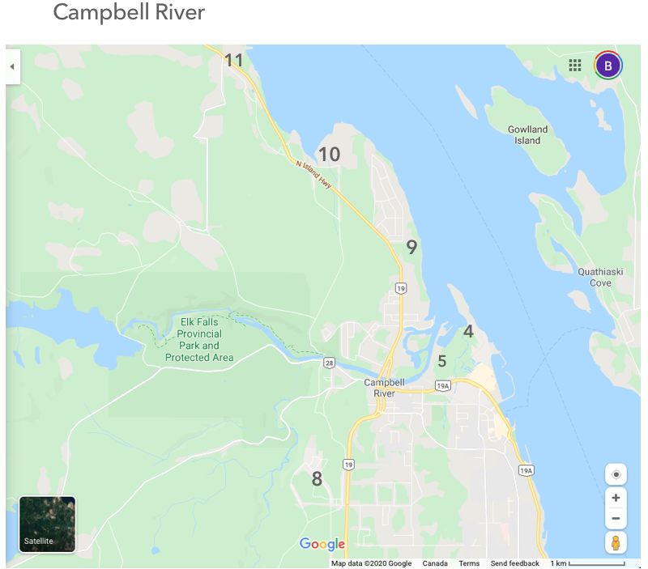

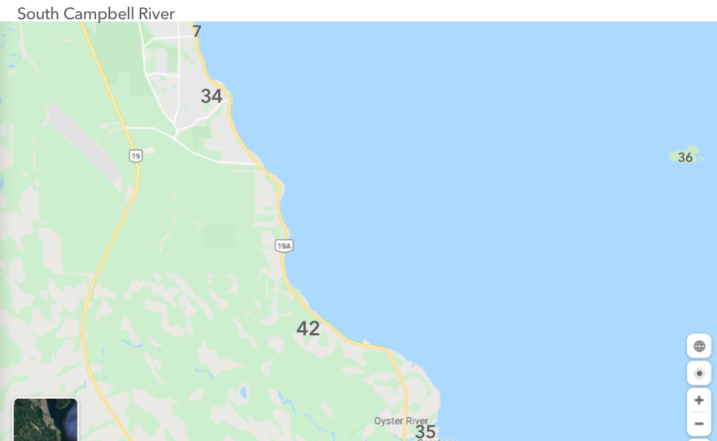

**Ǧilakasla to:**

**First Peoples Cultural Council**

**Indigenous Heritage Micro Grants**

**For making this possible**

